March 25
Today's Submissions: Story/ Magazine or Contest
□
□
□
Literary Magazine of the day:
Website:https://www.pennreview.org/
Editor:Daniel Finkel

1/20-2/24 & 3/10-4/21

SS = Yes
Today's Writing Goals:
□
□
□
Today's Reading Goals:
□
□
□
The Penn Review
Monday
Word Count
Goal:
Actual:
Morning Pages
□Yes □No
Today's Best Story Idea:
Write two paragraphs: the first presents an abstract theory; the second supports it with specific details.

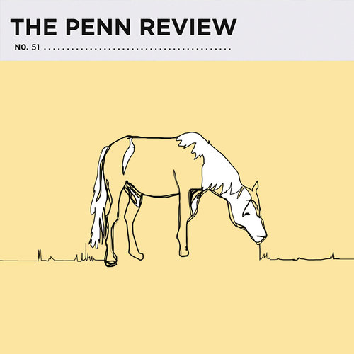

The Penn Review is a biannual print and online publication. They appear to be excited about having a very quick response time, getting back to authors in 2-3 days.

Hourly Plans
Exercise
Healthy Meals
Best/Biggest Surprise:
End of Day Evaluation: What did I learn? What worked/ What didn't?
8 am
9 am
10 am
11 am
12 pm
1 pm
2 pm
3 pm
4 pm
5 pm
6 pm
7 pm
8 pm
9 pm

March 26
Write a series of adverbial phrases in which the adverb contradicts the verb. Write a paragraph using your favorites.
Today's Submissions: Story/ Magazine or Contest
□
□
□
Editor:D. Laserbeam

3/1-7/31 & 9/1-1/31
$10
SS = Yes
Today's Writing Goals:
□
□
□
Today's Reading Goals:
□
□
□
Freeze Frame Fiction
Tuesday
Word Count
Goal:
Actual:
Morning Pages
□Yes □No
Today's Best Story Idea:
Freeze Frame Fiction is an online flash fiction magazine. All genres, no content restriction.

Literary Magazine of the day:



Website:https://freezeframefiction.com/write/submission-guidelines-faq/

Hourly Plans
Exercise
Healthy Meals
Best/Biggest Surprise:
End of Day Evaluation: What did I learn? What worked/ What didn't?
8 am
9 am
10 am
11 am
12 pm
1 pm
2 pm
3 pm
4 pm
5 pm
6 pm
7 pm
8 pm
9 pm


March 27
Pick a symbolic object. Describe it as thoroughly as you can. Use all five (six) senses. Write a scene in which the object becomes vital to the main character.
Today's Submissions: Story/ Magazine or Contest
□
□
□
Literary Magazine of the day:
Website:http://thecollagist.com/
Editor: Andrew Farkas and Emily Alex
3/1-7/31 &10/1-1/31
SS = Yes
Today's Writing Goals:
□
□
□
Today's Reading Goals:
□
□
□
The Collagist
Wednesday
Word Count
Goal:
Actual:
Morning Pages
□Yes □No
Today's Best Story Idea:

The Collagist is published online once every two months on the 15th. They are proud to be an imprint of Dzanc Books.

Hourly Plans
Exercise
Healthy Meals
Best/Biggest Surprise:
End of Day Evaluation: What did I learn? What worked/ What didn't?
8 am
9 am
10 am
11 am
12 pm
1 pm
2 pm
3 pm
4 pm
5 pm
6 pm
7 pm
8 pm
9 pm

□
March 28
Your main character creates a recipe--food, elixer, concoction--to ward off something. What is in it? How are the ingredients chosen? Does it work? What is it meant to defend and why?
Today's Submissions: Story/ Magazine or Contest
□
□
Literary Magazine of the day:
Website:www.heroicfantasyquarterly.com
Editor:Adrian Simmons & David Farneyl
March, June, Sept.
$25-100
SS = Yes
Today's Writing Goals:
□
□
□
Today's Reading Goals:
□
□
□
Heroic Fantasy Quarterly
Thursday
Word Count
Goal:
Actual:
Morning Pages
□Yes □No
Today's Best Story Idea:
Heroic Fantasy Quarterly is an online magazine that publishing heroic fantasy with a goal of “elevating unapologetic sword and sorcery to a rightful high place.”

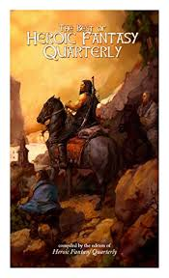

Hourly Plans
Exercise
Healthy Meals
Best/Biggest Surprise:
End of Day Evaluation: What did I learn? What worked/ What didn't?
8 am
9 am
10 am
11 am
12 pm
1 pm
2 pm
3 pm
4 pm
5 pm
6 pm
7 pm
8 pm
9 pm

March 29
Randomly pick one line from a religious text. If you saw that line painted on a wall with no idea where it came from, what would you think it meant? How would you react to it? How would your character react? Write a scene.
Today's Submissions: Story/ Magazine or Contest
□
□
□
Literary Magazine of the day:
Website:http://matterpress.com/submissions/
Editor: Randall Brown
3/15-6/15 & 9/15-12/15
$50

SS = Yes
Today's Writing Goals:
□
□
□
Today's Reading Goals:
□
□
□
Compressed Journal of Creative Arts
Friday
Word Count
Goal:
Actual:
Morning Pages
□Yes □No
Today's Best Story Idea:

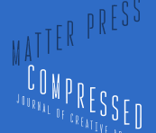

The Journal of Compressed Creative Arts is an online journal of micro and flash. They are interested in what “compression” means to the author, how you choose to “compress” your story.

Hourly Plans
Exercise
Healthy Meals
Best/Biggest Surprise:
End of Day Evaluation: What did I learn? What worked/ What didn't?
8 am
9 am
10 am
11 am
12 pm
1 pm
2 pm
3 pm
4 pm
5 pm
6 pm
7 pm
8 pm
9 pm

March 30
There's loud music coming from next door. How does your character react?
Today's Submissions: Story/ Magazine or Contest
□
□
□
Literary Magazine of the day:
Today's Writing Goals:
□
□
□
Today's Reading Goals:
□
□
□
Saturday
Word Count
Goal:
Actual:
Morning Pages
□Yes □No
Today's Best Story Idea:

LitMag

Editor:Marc Berley
2/1-5/31 & 9/1-11/30
3(rf) $250-$1,000
SS = Yes
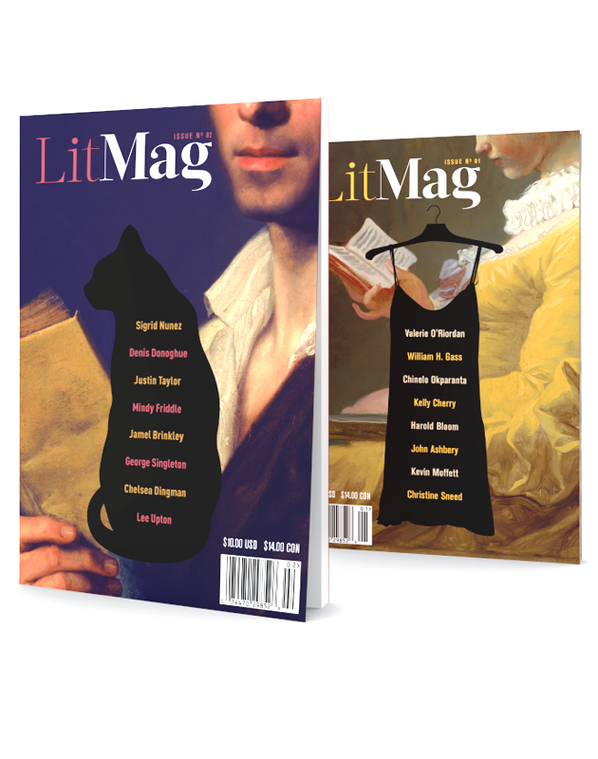

Website:https://litmag.com/

Lit Mag is a print magazine with online exclusives. It's first issue came out in 2017. They are looking for big minds and large hearts.

Hourly Plans
Exercise
Healthy Meals
Best/Biggest Surprise:
End of Day Evaluation: What did I learn? What worked/ What didn't?
8 am
9 am
10 am
11 am
12 pm
1 pm
2 pm
3 pm
4 pm
5 pm
6 pm
7 pm
8 pm
9 pm

March 31
Your character is yelling positive exclamations: Wow! Terrific! Excellent! Fantastic! What is happening?
Today's Submissions: Story/ Magazine or Contest
□
□
□
Literary Magazine of the day:
Website:https://www.drumlitmag.com/index.php?page=accordion&family=submissions
Today's Writing Goals:
□
□
□
Today's Reading Goals:
□
□
□
The Drum
Sunday
Word Count
Goal:
Actual:
Morning Pages
□Yes □No
Today's Best Story Idea:


Editor: Henriette Lazaridis
1/1-3/31
3(rf) $50
SS = Yes

The Drum is a quarterly published exclusively in audio format which you can listen to online or download.

Hourly Plans
Exercise
Healthy Meals
Best/Biggest Surprise:
End of Day Evaluation: What did I learn? What worked/ What didn't?
8 am
9 am
10 am
11 am
12 pm
1 pm
2 pm
3 pm
4 pm
5 pm
6 pm
7 pm
8 pm
9 pm

