
April 8
Your character just got fired. Why? What happens next?
Today's Submissions: Story/ Magazine or Contest
□
□
□
Literary Magazine of the day:
Website:http://ghostparachute.com/submissions/
Editor: Brett Pribble
Year round
no
SS = yes
Today's Writing Goals:
□
□
□
Today's Reading Goals:
□
□
□
Ghost Parachute
Word Count
Goal:
Actual:
Morning Pages
□Yes □No
Today's Best Story Idea:

Monday

Ghost Parachute is an online literary flash fiction magazine that aims to “ unleash the spider behind the rose and dance in the surreal.”

Hourly Plans
Exercise
Healthy Meals
Best/Biggest Surprise:
End of Day Evaluation: What did I learn? What worked/ What didn't?
8 am
9 am
10 am
11 am
12 pm
1 pm
2 pm
3 pm
4 pm
5 pm
6 pm
7 pm
8 pm
9 pm

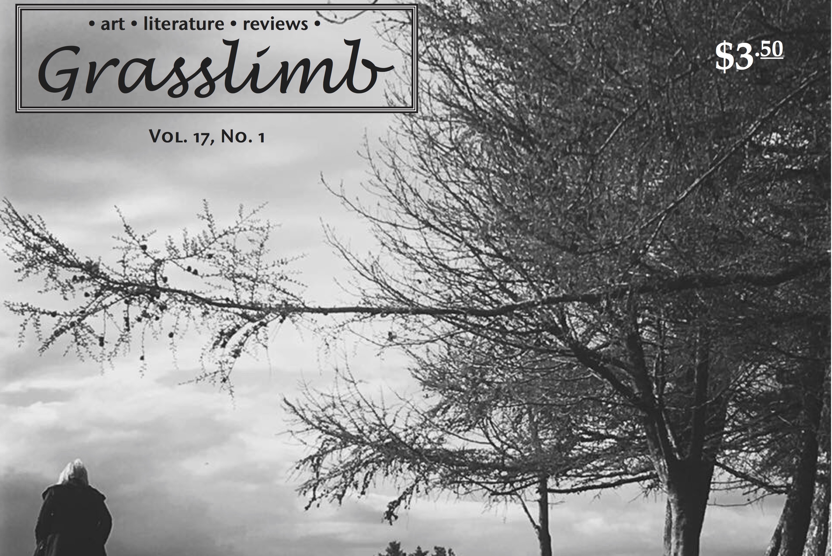
April 9
Your characters' marriage just imploded. Why? How? What will they do about it?
Today's Submissions: Story/ Magazine or Contest
□
□
□
Literary Magazine of the day:
Website:http://www.grasslimb.com/submissions.html
Editor: Valerie Polichar
Year round
$5-70
SS = yes
Today's Writing Goals:
□
□
□
Today's Reading Goals:
□
□
□
Grasslimb
Word Count
Goal:
Actual:
Morning Pages
□Yes □No
Today's Best Story Idea:

Tuesday

Grasslimb is a tabloid style print journal. They are looking for experimental, avant-garde and surreal prose of 1000-2000 words.

Hourly Plans
Exercise
Healthy Meals
Best/Biggest Surprise:
End of Day Evaluation: What did I learn? What worked/ What didn't?
8 am
9 am
10 am
11 am
12 pm
1 pm
2 pm
3 pm
4 pm
5 pm
6 pm
7 pm
8 pm
9 pm


April 10
Your character needs to know her future. Using a type of divination, tell what her future holds.
Today's Submissions: Story/ Magazine or Contest
□
□
□
Literary Magazine of the day:
Website:https://horroraddicts.wordpress.com/current-submission-calls/
Editor:Emerian Rich
Year round
$10
SS = Yes
Today's Writing Goals:
□
□
□
Today's Reading Goals:
□
□
□
Horror Addicts
Word Count
Goal:
Actual:
Morning Pages
□Yes □No
Today's Best Story Idea:
Horror Addicts has several submissions available: including a themed anthology and Friday flash fiction. Check the website for current listings.

Wednesday

Hourly Plans
Exercise
Healthy Meals
Best/Biggest Surprise:
End of Day Evaluation: What did I learn? What worked/ What didn't?
8 am
9 am
10 am
11 am
12 pm
1 pm
2 pm
3 pm
4 pm
5 pm
6 pm
7 pm
8 pm
9 pm


April 11
Someone in your story just found out they have a debilitating disease. How will they react? What will they do next?
Today's Submissions: Story/ Magazine or Contest
□
□
□
Literary Magazine of the day:
Websitehttp://www.iconoclastliterarymagazine.com/submissionguidelines/
Editor:
Phil Wagner
Year round
$.01/word & 2 cc
SS = No
Today's Writing Goals:
□
□
□
Today's Reading Goals:
□
□
□
Iconoclast
Word Count
Goal:
Actual:
Morning Pages
□Yes □No
Today's Best Story Idea:
Iconoclast is looking for poetry and prose from authors interested in the creation, sharing, and transmission of ideas, imaginings, and experiences.

Thursday

Hourly Plans
Exercise
Healthy Meals
Best/Biggest Surprise:
End of Day Evaluation: What did I learn? What worked/ What didn't?
8 am
9 am
10 am
11 am
12 pm
1 pm
2 pm
3 pm
4 pm
5 pm
6 pm
7 pm
8 pm
9 pm


April 12
Your character is mistaken for someone else. They decide to go with it. What happens?
Today's Submissions: Story/ Magazine or Contest
□
□
□
Literary Magazine of the day:
Website:http://thewifiles.com/?page_id=8
Editor:
Four Parts Press
Year round

$3
SS = Yes
Today's Writing Goals:
□
□
□
Today's Reading Goals:
□
□
□
The WiFiles
Word Count
Goal:
Actual:
Morning Pages
□Yes □No
Today's Best Story Idea:

Friday

The WiFiles is an online speculative fiction magazine, publishing one short story a week of between 1000 and 5000 words in length

Hourly Plans
Exercise
Healthy Meals
Best/Biggest Surprise:
End of Day Evaluation: What did I learn? What worked/ What didn't?
8 am
9 am
10 am
11 am
12 pm
1 pm
2 pm
3 pm
4 pm
5 pm
6 pm
7 pm
8 pm
9 pm


April 13
Collect ten to twenty strange (to you) facts. Find out as much as you can about them. Use all of them in a normal day of your character.
Today's Submissions: Story/ Magazine or Contest
□
□
□
Literary Magazine of the day:
Website:https://thirdwednesdaymagazine.org/fiction-submissions/
Editor: John F. Buckley

open

$3

SS = Yes
Today's Writing Goals:
□
□
□
Today's Reading Goals:
□
□
□
Third Wednesday
Word Count
Goal:
Actual:
Morning Pages
□Yes □No
Today's Best Story Idea:

Saturday

Third Wednesday is looking for prose of no more than 1,500 words. Shorter is better.

Best/Biggest Surprise:
8 am
9 am
10 am
11 am
12 pm
1 pm
2 pm
3 pm
4 pm
5 pm
6 pm
7 pm
8 pm
9 pm
Hourly Plans
Exercise

End of Day Evaluation: What did I learn? What worked/ What didn't?
Healthy Meals


April 14
Pick an artist you admire. Make a collage from several
of their works. Write a story inspired by your
collage.
Today's Submissions: Story/ Magazine or Contest
□
□
□
Literary Magazine of the day:
Website:http://www.riverstyx.org/submit/general-submissions/
Editor: Jason Lee Brown

open

$25-150
SS = yes
Today's Writing Goals:
□
□
□
Today's Reading Goals:
□
□
□
River Styx
Word Count
Goal:
Actual:
Morning Pages
□Yes □No
Today's Best Story Idea:

Sunday

twi

River Styx is a not for profit, independent magazine. They publish thoughtful yet accessible, unpredictable yet moving literature and art.

Hourly Plans
Exercise
Healthy Meals
Best/Biggest Surprise:
End of Day Evaluation: What did I learn? What worked/ What didn't?
8 am
9 am
10 am
11 am
12 pm
1 pm
2 pm
3 pm
4 pm
5 pm
6 pm
7 pm
8 pm
9 pm

