May 27
Your character owns a small flower shop in a small town. What are twenty conflicts that occur in the shop. Choose your favorite and write about it.
Today's Submissions: Story/ Magazine or Contest
□
□
□
Literary Magazine of the day:
Editor: Michael Ray

Opens June 1 look at website for new guidelines
SS = Yes
Today's Writing Goals:
□
□
□
Today's Reading Goals:
□
□
□
Zoetrope:All Story
Monday
Word Count
Goal:
Actual:
Morning Pages
□Yes □No
Today's Best Story Idea:



Website:https://www.all-story.com/

Zoetrope: All Story was started by Francis Ford Coppola in 1997. Along with short fiction, each issue includes a classic reprint of a story that inspired a film and each issue is designed buy a guest contemporary artist

Hourly Plans
Exercise
Healthy Meals
Best/Biggest Surprise:
End of Day Evaluation: What did I learn? What worked/ What didn't?
8 am
9 am
10 am
11 am
12 pm
1 pm
2 pm
3 pm
4 pm
5 pm
6 pm
7 pm
8 pm
9 pm

May 28
Jot down the plot points/main scenes of three PIXAR movies. Create a consensus outline. Fit your favorite horror movie into your outline. Does it fit? What's different? Use your outline for your new story.
Today's Submissions: Story/ Magazine or Contest
□
□
□
Literary Magazine of the day:
Today's Writing Goals:
□
□
□
Today's Reading Goals:
□
□
□
Apparition Lit
Tuesday
Word Count
Goal:
Actual:
Morning Pages
□Yes □No
Today's Best Story Idea:

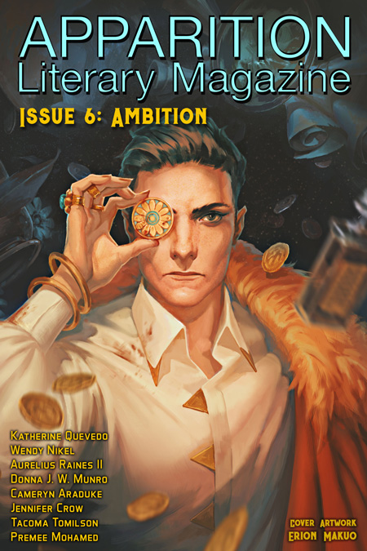
Editor: Tacoma Tomlinson
5/1-6/7
$.03/word
Four themed reading periods
May 15-31 Retribution
SS = Yes

Website:https://www.apparitionlit.com/

Apparition Lit is looking for original speculative fiction that meets their quarterly themes.

Hourly Plans
Exercise
Healthy Meals
Best/Biggest Surprise:
End of Day Evaluation: What did I learn? What worked/ What didn't?
8 am
9 am
10 am
11 am
12 pm
1 pm
2 pm
3 pm
4 pm
5 pm
6 pm
7 pm
8 pm
9 pm

May 29
You're a director and your characters are all over-acting. Write that scene. How would you ask them to play the scene differently? Re-write the scene
Today's Submissions: Story/ Magazine or Contest
□
□
□
Literary Magazine of the day:
Editor: Mark Drew

9/1-5/31

SS = Yes
Today's Writing Goals:
□
□
□
Today's Reading Goals:
□
□
□
The Gettysburg Review
Wednesday
Word Count
Goal:
Actual:
Morning Pages
□Yes □No
Today's Best Story Idea:



Website:http://www.gettysburgreview.com/

The Gettysburg Review has been published by Gettysburg College since 1988. They “look for writers who can shape language in thoughtful, surprising, and beautiful ways and who have something unique to say, whatever the subject matter or aesthetic approach.”

Hourly Plans
Exercise
Healthy Meals
Best/Biggest Surprise:
End of Day Evaluation: What did I learn? What worked/ What didn't?
8 am
9 am
10 am
11 am
12 pm
1 pm
2 pm
3 pm
4 pm
5 pm
6 pm
7 pm
8 pm
9 pm

May 30
One day you decide to wear the same costume 24/7 for the rest of your life. What happens?
Today's Submissions: Story/ Magazine or Contest
□
□
□
Literary Magazine of the day:
Editor: Owen Kaelan
Beth Gordon

June 1

SS = Yes
Today's Writing Goals:
□
□
□
Today's Reading Goals:
□
□
□
Gone Lawn
Thursday
Word Count
Goal:
Actual:
Morning Pages
□Yes □No
Today's Best Story Idea:
Gone Lawn is looking for “sincere, well-written, imaginative, unusual and/or innovative works that charm and displace us, that baffle the pale-setters of our rolling, verdant isles and nab all their dreary tools. Gone Lawn is especially partial to odd animals.”



Website:http://journal.gonelawn.net/glj_submit.php

Hourly Plans
Exercise
Healthy Meals
Best/Biggest Surprise:
End of Day Evaluation: What did I learn? What worked/ What didn't?
8 am
9 am
10 am
11 am
12 pm
1 pm
2 pm
3 pm
4 pm
5 pm
6 pm
7 pm
8 pm
9 pm

May 31
You are the first__________ wrestler. Why did you decide to get in the ring? Are you the hero or the villain? What does your costume look like? What is your big move? What is your fake story within the real story? Do your two lives become hard to separate?
Today's Submissions: Story/ Magazine or Contest
□
□
□
Literary Magazine of the day:
Editor: Mallory Smart

Year round

SS = Yes
Today's Writing Goals:
□
□
□
Today's Reading Goals:
□
□
□
Maudlin House
Friday
Word Count
Goal:
Actual:
Morning Pages
□Yes □No
Today's Best Story Idea:



Website:https://maudlinhouse.net/

Maudlin House is an online journal that appreciates all forms of transgressive, absurdist, and minimalist literature.

Hourly Plans
Exercise
Healthy Meals
Best/Biggest Surprise:
End of Day Evaluation: What did I learn? What worked/ What didn't?
8 am
9 am
10 am
11 am
12 pm
1 pm
2 pm
3 pm
4 pm
5 pm
6 pm
7 pm
8 pm

9 pm

