June 3
You've been trying to find work for a year. Your first day on the job you discover your boss is a criminal. What happens next?
Today's Submissions: Story/ Magazine or Contest
□
□
□
Literary Magazine of the day:
Today's Writing Goals:
□
□
□
Ploughshares
Monday
Word Count
Goal:
Actual:
Morning Pages
□Yes □No
Ploughshares is published by Emerson College in Boston. It is one of the very top journals to strive for, if you're looking for literary attention.

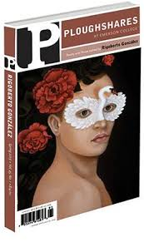
Editor:
Ladette Randolph
Poetry editor: John Skoyles
6/1-1/15
$45/page
SS = Yes

Website:https://www.pshares.org/

Today's Reading Goals:
□
□
□

Today's Best Story Idea:

Hourly Plans
Exercise
Healthy Meals
Best/Biggest Surprise:
8 am
9 am
10 am
11 am
12 pm
1 pm
2 pm
3 pm
4 pm
5 pm
6 pm
7 pm
8 pm
9 pm

End of Day Evaluation: What did I learn? What worked/ What didn't?

June 4
Create a characte that always says the wrong thing. She sounds guilty of something even though she's never done anything wrong.
Today's Submissions: Story/ Magazine or Contest
□
□
□
Literary Magazine of the day:
Website:https://granta.com/
Poetry Editor:
Rachael Allen
6/7

SS = Yes
Today's Writing Goals:
□
□
□
Today's Reading Goals:
□
□
□
Granta
Tuesday
Word Count
Goal:
Actual:
Morning Pages
□Yes □No
Today's Best Story Idea:
Granta is another very heavy hitter. Granta is open for poetry this week.
I highly recommend submitting. They don't open for fiction until October. I'll do another entry then.

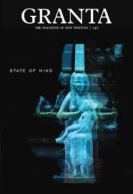

Hourly Plans
Exercise
Healthy Meals
Best/Biggest Surprise:
End of Day Evaluation: What did I learn? What worked/ What didn't?
8 am
9 am
10 am
11 am
12 pm
1 pm
2 pm
3 pm
4 pm
5 pm
6 pm
7 pm
8 pm
9 pm

June 5
Your character gets in legal trouble for solving a crime.
Today's Submissions: Story/ Magazine or Contest
□
□
□
Literary Magazine of the day:
Website:http://www.wintertangerine.com/
Editor:
Jake Stone
Poetry editor:
Xandria Phillips
Currently open
$50
SS = Yes
Today's Writing Goals:
□
□
□
Today's Reading Goals:
□
□
□
Winter Tangerine
Wednesday
Word Count
Goal:
Actual:
Morning Pages
□Yes □No
Today's Best Story Idea:
Winter Tangerine wants the electric. They aim to disrupt the status quo and amplify the unheard.

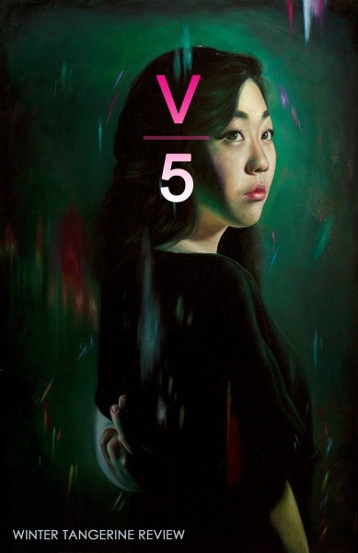

Hourly Plans
Exercise
Healthy Meals
Best/Biggest Surprise:
End of Day Evaluation: What did I learn? What worked/ What didn't?
8 am
9 am
10 am
11 am
12 pm
1 pm
2 pm
3 pm
4 pm
5 pm
6 pm
7 pm
8 pm
9 pm

June 6
Today's Submissions: Story/ Magazine or Contest
□
□
□
Literary Magazine of the day:
Website:https://ycny.org/stone-canoe-information
Today's Writing Goals:
□
□
□
Today's Reading Goals:
□
□
□
Stone Canoe
Thursday
Word Count
Goal:
Actual:
Morning Pages
□Yes □No
Today's Best Story Idea:
Stone Canoe is published by the YMCA's Downtown Writers Center, at the Arts Branch of the YMCA of Greater Syracuse. The annual publication appears each February. They only accept work by current or former residents of Upstate New York.
Your character has a blind spot. What can't s/he see?



Hourly Plans
Exercise
Healthy Meals
Best/Biggest Surprise:
End of Day Evaluation: What did I learn? What worked/ What didn't?
8 am
9 am
10 am
11 am
12 pm
1 pm
2 pm
3 pm
4 pm
5 pm
6 pm
7 pm
8 pm
9 pm

June 7
Your character excites someone by bringing him/her in on his/her plan.
Today's Submissions: Story/ Magazine or Contest
□
□
□
Literary Magazine of the day:
Website:https://theblendinternational.com.au/
Editor:
Sarah Knight
open
$50

SS = Yes
Today's Writing Goals:
□
□
□
Today's Reading Goals:
□
□
□
The Blend
Friday
Word Count
Goal:
Actual:
Morning Pages
□Yes □No
Today's Best Story Idea:
The Blend Internation Literature is a new journal out of Australia. Hurry and submit for their first issue.



Hourly Plans
Exercise
Healthy Meals
Best/Biggest Surprise:
End of Day Evaluation: What did I learn? What worked/ What didn't?
8 am
9 am
10 am
11 am
12 pm
1 pm
2 pm
3 pm
4 pm
5 pm
6 pm
7 pm
8 pm
9 pm

June 8
You wake up and find a stranger in your room. You grab what's on your bedstand and strike. What did you kill him with? What happens?
Today's Submissions: Story/ Magazine or Contest
□
□
□
Literary Magazine of the day:
Website:https://tahomaliteraryreview.com/
Editor:
Jim Gearhart

5/7-7/31
$5rf $55-$135

SS = Yes
Today's Writing Goals:
□
□
□
Today's Reading Goals:
□
□
□
Tahoma Literary Review
Saturday
Word Count
Goal:
Actual:
Morning Pages
□Yes □No
Today's Best Story Idea:
“A major goal of Tahoma Literary Review is to show that writers and publishers can support each other not only artistically, but also financially.”

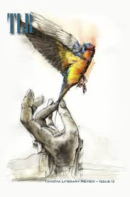

Hourly Plans
Exercise
Healthy Meals
Best/Biggest Surprise:
End of Day Evaluation: What did I learn? What worked/ What didn't?
8 am
9 am
10 am
11 am
12 pm
1 pm
2 pm
3 pm
4 pm
5 pm
6 pm
7 pm
8 pm
9 pm

June 9
Your character is intoduced to a group of people who are the absolute opposite of expectation.
Today's Submissions: Story/ Magazine or Contest
□
□
□
Literary Magazine of the day:
Website:https://twohawksquarterly.com/
Editor:
Students

open

SS = Yes
Today's Writing Goals:
□
□
□
Today's Reading Goals:
□
□
□
Two Hawks Quarterly
Sunday
Word Count
Goal:
Actual:
Morning Pages
□Yes □No
Today's Best Story Idea:
Two Hawks Quarterly is produced by the BA Program at Antioch University Los Angeles. They have a section for works that defy genre classification, called Genre X.

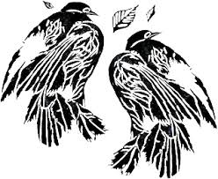

Hourly Plans
Exercise
Healthy Meals
Best/Biggest Surprise:
End of Day Evaluation: What did I learn? What worked/ What didn't?
8 am
9 am
10 am
11 am
12 pm
1 pm
2 pm
3 pm
4 pm
5 pm
6 pm
7 pm
8 pm
9 pm

